**Object Oriented Programming**



**Lab Report #2**

|  |  |
| --- | --- |
| Name | Ali Salman |
| Registration no. | FA22-BCE-005 |
| Class | BCE- 4 |
| Instructor’s Name | Prof. Tayyab Rasul |

**Lab 2: Classes and Data Abstraction**

**Task 1:**

Write a class that displays a simple message “I am object no. __”, on the screen whenever an object of that class is created.

**Program:**

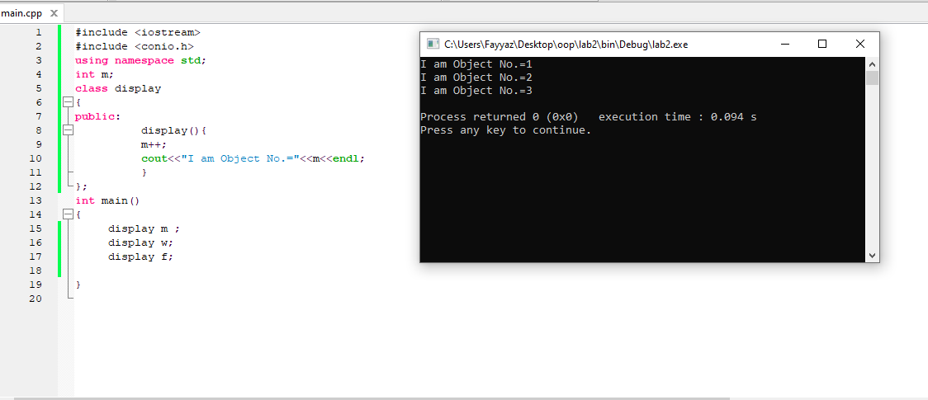

**Output:**

**Task 2:**

Create a class that imitates part of the functionality of the basic data type int, call the class Int. The only data in this class is an integer variable. Include member functions to initialize an Int to zero, to initialize it to an integer value and to display it. Write a program that exercises this class by creating an Int variable and calling its member functions.

**Program:**

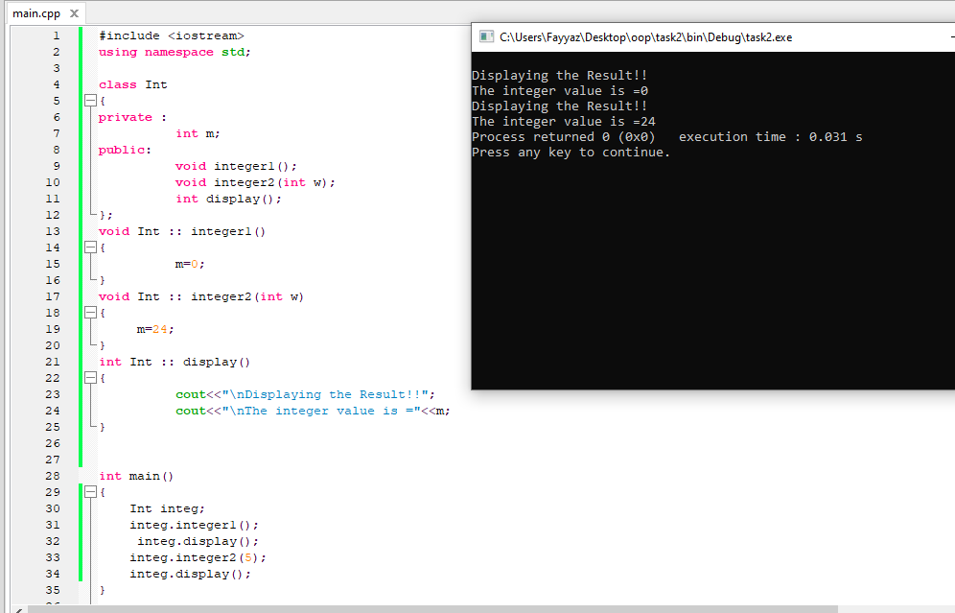

**Output:**



**Hometask 1:**

Write a program to calculate the number of objects created and destroyed for the counter class.

**Program:**

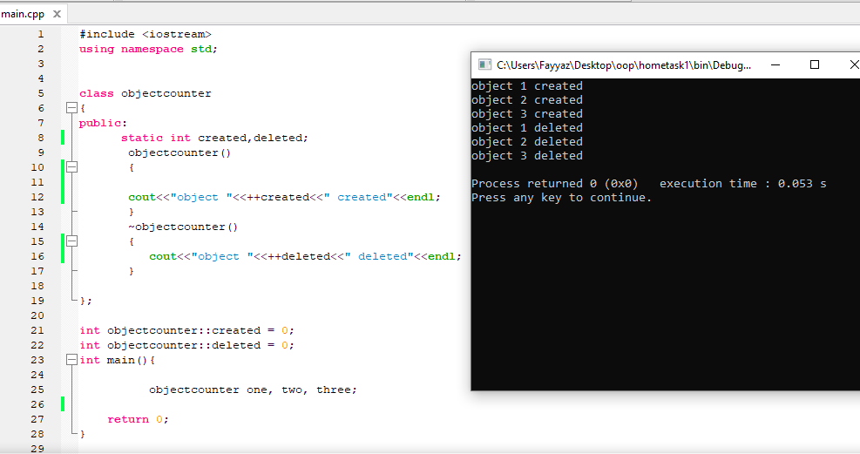

**Output:**



**Home-task 2:**

Create a class named time, the data members are hours, minutes and seconds. Write a function to read the data members supplied by the user, write a function to display the data members in standard (24) hour and also in (12) hour format.

**Program:**

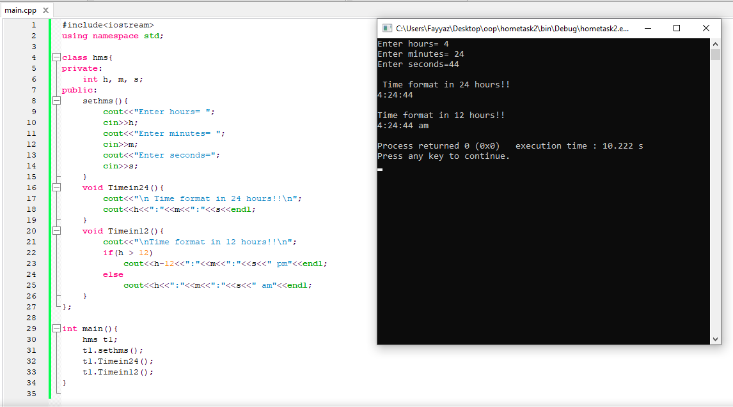

**Output:**



**Home-task 3:**

Write a class marks with three data members to store three marks. Write three member functions,

set_marks () to input marks, sum() to calculate and return the sum and avg() to calculate and

return average marks.

**Program:**

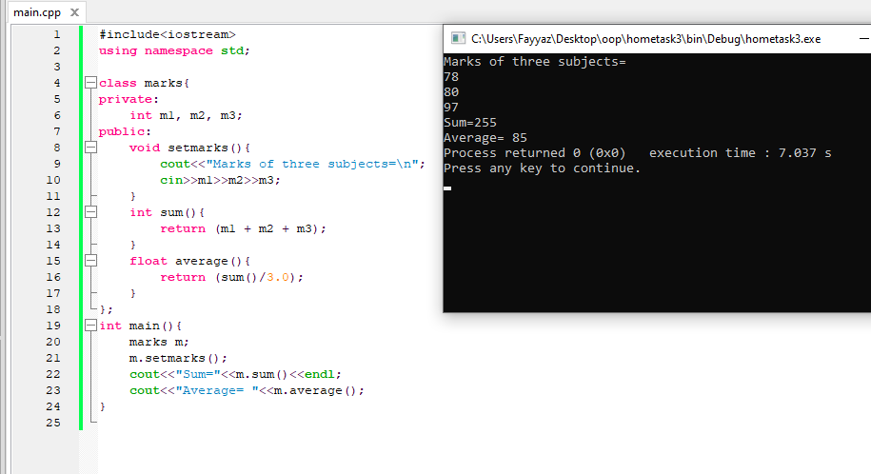

**Output:**



**Critical Analysis:**

In this lab, we learned the importance of classes and the construction of objects using classes.

We learned to declare classes, objects, member functions, and member variables of a class. We understood the importance and use of constructors and destructors. The C++ compiler either creates or allows the user to define the class's special member functions, the Constructor and Destructor. The constructor is utilized to instate the object of the class while the destructor is called by the compiler when the item is obliterated.

We understood the minute difference between syntax of declaring a class and constructor. We identified and concentrated on important aspects of a situation or object, as well as removing or filtering out undesirable aspects. We also experienced the use of constructor with parameter and without parameter.